levan cagareli

arno Smiti – germaneli joisi

2007

TiToeul evropul qveyanaSi modernizmis cnebas ukavSirdeba XX saukunis romelime didi mwerlis saxeli. irlandiaSi aseTi gaxldaT – jeims joisi, safrangeTSi – marsel prusti, avstriaSi – herman broxi. Tumca am mwerlebs aerTianebdaT mxolod epoqa, literaturuli tradiciebis msxvrevisa da axali literaturuli formebis Seqmnisken swrafva, xolo stilisa da formaluri maxasiaTeblebis mxriv maTi Semoqmedeba sruliad gansxvavebulia. amis miuxedavad evropeli mwerlebi yovelTvis did gavlenas axdendnen erTmenTze da amrigad, savsebiT kanonzomieri iqneba, Tu romelime didi evropeli mwerlis kvals misi romelime kolegis SemoqmedebaSi aRmovaCenT.
aseTTa ricxvs ganekuTvneba germaneli mwerali arno Smitic (1914-1979). volfgang koepenTan erTad arno Smitic germanuli gviandeli modernizmis TvalsaCino warmomadgenelia. mocemul narkvevSi SevecdebiT gavyveT im kvals, romelic arno Smitis Semoqmedebaze ulises saxelovanma avtorma datova.
mkvlevrebi gamoyofen arno Smitis adreul da gviandel Semoqmedebas. jeims joisis Semoqmedebis aRmoCenam da froidis fsiqoanalizis Seswavlam, rac savaraudod 1956 wlis Semdeg unda momxdariyo, didi gavlena moaxdina arno Smitis Semoqmedebaze misi cxovrebis ukanaskneli 20 wlis ganmavlobaSi.
arno SmitisTvis jeims joisis literaturuli memkvidreobis mniSvnelobaze mowmobs mravalricxovani narkvevebi da naSromebi, romlebSic germaneli avtori saTayvanebeli mwerlis Semoqmedebis problemebs ganixilavda. am mxriv aRsaniSnavia krebuli tritoni qolgiT (Der Triton mit dem Sonnenschirm. Großbritanische Gemütsergetzungen, 1969 w.), romelSic Sesulia naSromebi ara mxolod inglisuri, aramed amerikuli literaturis Sesaxebac: fenimor kuperis konanCetis germanulenovani Targmanis komentari, kritikuli werili misive yvavebis budis Semoklebuli germanulenovani Targmanis gamo, narkvevi edgar alan pos aSerebis saxlis Sesaxeb, romelic arno Smitma Targmna. Tumca gansakuTrebuli adgili aRniSnul wignSi ukavia oTx naSroms jeims joisisa da misi fineganis qelexis Sesaxeb. danarCeni narkvevebi eTmoba deb bronteebs, balueris romans amas ras uzams?, Carlz dikenss, uilki kolinsis nawarmoebs – qali TeTr kabaSi, romlis Targmanic agreTve arno Smits ekuTvnis. TiToeuli maTgani 1960-1969 wlebSi gadaica radioTi. tritonis popularoba ganpirobebuli iyi gamomcemlis mier wignis ydaze ganTavsebuli gancxadebiT, romlis Tanaxmadac, zemoxsenebuli werilebi did samsaxurs gauwevda mkiTxvels arno Smitis mTavar nawarmoebSi – gamosacemad momzadebul fskeras sizmarSi garkvevisas.
jeims joisis Semoqmedebis kvlevisas arno Smiti waawyda mis naklebad saxelovan Zmas stanislaus joiss, romlis ori nawarmoebic (Cemi Zmis mfarvelebi da stanislaus joisis dublinuri dRiuri) Tavad Targmna germanul enaze. stanislaus joisis orive wignis gadaTargmnis Semdeg arno Smits daebada idea, daewera fineganis qelexis axali interpretacia, romelic man 1960 wlis dekemberSi marTlac gamoaqveyna Jurnal caitSi. jeims joisis es gviandeli rTuli nawarmoebi arno Smitma ganixila rogorc erTi niWieri Zmis SeniRbuli brZola meore, naklebad niWieri Zmis winaaRmdeg. am pirvelma interpretaciam ubiZga arno Smits daewyo fineganis qelexidan momcro nawilebis Targmna da komentireba. Tumca mis gegmas, daewera nawarmoebis amomwuravi komentari an pirvels eTargmna igi germanulad, ganxorcieleba ar ewera. arno Smitma mraval gamomcemlobas SesTavaza, xuTi wlis vadaSi mizeruli Tanxis sanacvlod (36000 marka) gadaeTargmna msoflio literaturis es Sedevri, Tumca amis msurveli aravin gamoCnda.
amis miuxedavad arno Smitma mniSvnelovnad Seuwyo xeli inglisuri literaturis Sedevrebis Targmnas germanul enaze. swored misi miTiTebiT Targmna hans volSlegerma jeims joisis ulise (1975 w.), mogvianebiT iTargmna fineganis qelexi (mTargmneli: diter Stiundeli, 1993 w.), debi bronteebis angria & gondali (mTargmneli: hans Siuci, 1987 w.), lorens sternis tristram Sendi (mTargmneli: mihael valteri, 1994 w.), liuis kerolis Semoqmedeba srulad (mTargmneli: diter Stiundeli, 1996 w.).
rogorc zemoT aRvniSneT, 60-ian wlebSi arno Smiti iwyebs Tavisi poetologiuri principebis Teoriul aRwera-dasabuTebas, qmnis e.w. etimTa Teorias. etimTa Teoria TiToeuli sityvis miRma mis farul da namdvil mniSvnelobas moiazrebs. etimistika erTgvari kodia, romlis meSveobiTac SesaZlebelia gaiSifros TiToeul teqstSi Cadebuli (yovelTvis seqsualuri) arsi.
aRniSnul Teorias mWidrod ukavSirdeba meoTxe fsiqikuri instanciis cneba. ramdenadac cnobilia, zigmund froidis moZRvrebis Tanaxmad, arsebobs sami fsiqikuri instancia: 1. aracnobieri, seqsualuri survilebisa da faruli vnebebis erToblioba; 2. me, romelic warmoiqmneba garesamyarosTan individis urTierTobis Sedegad; da 3. ze-me, moraluri akrZalvebis erToblioba, romelic mSoblebisa da sazogadoebis gavleniT uviTardeba individs. arno Smitma garkveuli cvlilebebi Seitana zigmund froidis moZRvrebaSi: arsebul sam instancias man meoTxe fsiqikuri instancia daumata. es ukanaskneli, mwerlis azriT, inteleqtualur individs uviTardeba ormocdaaTi wlis asakSi, impotenciis dawyebasTan erTad. esaa iumoristuli instancia, romelic aracnobier leqsikas flobs da iyenebs mas xumrobisa da SemoqmedebiTi saqmianobis dros. ismis kiTxva: ratom ver aRmoaCina mocemuli instancia TviT zigmund froidma? arno Smitis ganmartebiT, fsiqoanalizis mamamTavars arasdros hyolia ormocdaaT wels gadacilebuli inteleqtuali pacientebi. swored am meoTxe instancias ZaluZs aRmoaCinos enis orazrovneba da weros etimisturad.
arno Smiti Seecada etimistur WrilSi gaeazrebina Tavisi sayvareli avtorebis – karl meis, jeims joisisa da edgar alan pos Semoqmedeba. Tumca peter arentis azriT, am avtorebisadmi miZRvnili naSromebi erTgvari proeqciaa TviT arno Smitis aracnobierisa, asakovani mwerlis mier sakuTari Tavis gaanalizebis cda (arenti 1995:314). etimTa Teoria ki sxva arferia Tu ara fsevdomecnieruli, sruliad spekulaciuri Tvalsazrisi, romliTac ormocdaaT wels gadacilebuli mwerali Tavisi literaturuli stilisa da eqsperimentuli enis dasabuTebas cdilobs.
SemoqmedebiT praqtikaSi etimTa Teoria xorcieldeba sityvaTa TamaSis saxiT, romlis Sedegadac warmoiqmneba mravalmniSvnelovani leqsikuri erTeulebi, ufro metic: TviT teqsti, masSi gadmocemuli mxatvruli samyaro da moTxrobili ambebic orazrovani xdeba. aseTi sityvebia: “BukePhallus” (bucefali+falosi), “Eroplan” (aeroplani+erosi), “Phallke” (Sevardeni+falosi), “Nachlässichcoit” (udiereba+koitusi), “Ärscheinung” (gamosaxuleba+ukanali), “Vaginabundin” (vagabundi+vagina), “Santa Lutschia” (wminda luCia+wuwna), “Lecktion” (leqcia+lokva), “Posaunen” (sayvirebi+ukanali), “Penix” (feniqsi+penisi), “Nacktigall” (SiSveli+bulbuli). nawilobriv etimisturi da nawilobriv sityvaTa Cveulebrivi TamaSis Sedegad Seqmnili sityvebi mkiTxvelis yuradRebas amaxvilebs ara TavianT polisemiurobaze, aramed TavianT formaze. sityvebi, rogoricaa „Zwielisation“ (civilizacia+mwuxri), „rAffiniert“ (rafinirebuli+maimuni), „ScHerzgestalt“ (xumroba+guli+saxe), „FREUD=Ich“ (froidi+me+mxiarulad), „Cannibaalismus“ (kanibalizmi+baali), „DisKuß’ionen“ (diskusiebi+ambori), „brülljant“ (SesaniSnavi+Rriali), „schwermythich“ (sevdiani+miTosuri), „Ladyglich“ (ledi+mxolod), „Gammelien-Dame“ (moxetiale+qali kameliebiT), „Genussinnen“ (amxanagebi+tkboba) da sxv. damatebiT mniSvnelobebs iZens Tavisi grafemuli formis safuZvelze. aq vlindeba ara mTxrobeli subieqtis aracnobieri, aramed “TamaSis momenti, romelic [...] SmitTan sul ufro dominanturi gaxda, gamokvlevebSi ki arasdros gaumaxvilebiaT masze yuradReba” (albrehti 1998:107). esaa TamaSi enobrivi mniSvnelobebiT, TamaSi, romelic gamoricxavs yovelgvar erTmniSvnelovnebas da mxolod imisTvis gamodgeba, raTa gansjis obieqtad TviT ena aqcios.
jeims joisis mier farTod gamoyenebul teqnikas cnobierebis nakadisa Zalze hgavs e.w. axali prozauli formebi, romelTa tipologiac arno Smitma Tavis Teoriul naSromebSi – gamoangariSebani I da gamoangariSebani II-Si ganaviTara. XVIII s. Camoyalibebuli literaturuli Janrebis (romani, novela, epistolaruli romani, dRiuri, dialogi) safuZvelze igi aviTarebs iseT prozaul formebs, romelTac ZaluZT zustad gadmoscen, asaxon cnobierebaSi mimdinare garkveuli procesebi da gancdebi. Tavdapirvelad man SearCia oTxi fsiqikuri faqti, Seiswavla isini da Teoriulad daasabuTa maTi literaturuli ganxorcielebis SesaZlebloba. esenia mogoneba (Erinnerung), axlo warsuli (Jüngste Vergangenheit), azrTa xangrZlivi TamaSi (Längeres Gedankenspiel) da sizmari (Traum). pirvel or literaturul xerxs eTmoba gamoangariSebani I, xolo momdevno ors – gamoangariSebani II. ganvixiloT TiToeuli maTgani:
1. mogoneba. mocemuli prozauli forma miznad isaxavs ‘mkveTri sityvebis TavmoyriTa’ (‘schärfste Wortkonzentrate’) da Txrobis aqtoruli perspeqtivis meSveobiT Seqmnas namdvili mogonebebis iluzia. TiToeul mogonebas safuZvlad udevs erTgvari suraTi (arno Smitis terminologiiT – ‘foto’), romelic wuTierad cocxldeba adamianis cnobierebaSi. mis irgvliv jgufdeba damatebiTi detalebi (‘teqstebi’). amgvari literaturuli formis mqone teqsts arno Smiti uwodebs ‘fotoalboms’. ‘fotoalbomSi’ ‘fotoebi’ namdvili suraTebis msgavsad CarCoSia Casmuli da ‘teqstis’ win Tavsdeba. teqstebisa da fotoebis ricxvsa da sigrZes gansazRvravs moqmedebis tempi. moqmedebis tempisa da mogonebebis urTierTqmedebis aRsawerad arno Smitma specialuri cxrilic ki SeimuSava. cxrilSi igi erTmaneTs ukavSirebs calkeul Temasa da garkveul maTematikur mruds. dagegmili rva Temidan mweralma mxolod ori ganaxorciela Tavis nawarmoebebSi – gadasaxlebulni da tbiani landSafti pokahontasTan erTad.
2. axlo warsuli – wyvetili awmyo. aRniSnul prozaul formas safuZvlad udevs mosazreba, rom movlenaTa epikuri, uwyveti dineba ar arsebobs: “SuaRamidan SuaRamemde ‘1 dRe’ ki ar aris, aramed ‘1440 wuTi’ (romelTagan ormocdaaTiode Tua mniSvnelovani!)” (Smiti 1995:167). saWiro iyo wyvetilobis Sesabamisi literaturuli xerxis SemuSaveba, romelic asaxavda ara epikur Tanmimdevrobas, aramed ‘dRis mozaikas’, ‘wyvetil, mozaikur yofierebas’. Txrobis es xerxi Semoifargleba ‘mniSvnelovani’ wuTebis gadmocemiT. am xerxiT Sesrulebuli teqstis formaluri niSania kursiviT gamoyofili, winwamoweuli abzacebi. SemuSavebuli TxuTmeti Tematuri variantidan arno Smitma mxolod rva ganaxorciela. axlo warsulis amsaxveli prozauli struqtura gvxvdeba Semdeg teqstebSi: enTimezisi, leviaTani (aq gamonaklisis saxiT pirveli striqoni mxolod kursiviTaa markirebuli), aleqsandre, brandis mdelo, Savi sarkeebi, favni, kozmasi, qvis guli, swavlulTa respublika, Tina da goeTe da misi erT-erTi Tayvanismcemeli.
3. azrTa xangrZlivi TamaSi da 4. sizmari. am ori prozauli formis saerTo maxasiaTebelia ormagi moqmedeba, romelic gancdis or sxvadasxva dones moicavs – gancdis done I (Erlebnisebene I, E I) da gancdis done II (Erlebnisebene II, E II). pirveli maTgani obieqtur sinamdviles Seesabameba, xolo meore – subieqtur sinamdviles. orsave SemTxvevaSi gancdili done I-is xvedriTi wili erTnairia. sizmarSi personaJi pasiuri mayureblis rolSi gamodis, igi mxolod aRiqvams, ganicdis subieqtur sinamdviles, xolo azrTa xangrZlivi TamaSis dros moqmedi piri aqtiuria, igi Tavad qmnis Tavis subieqtur sinamdviles.
azrTa xangrZlivi TamaSi (LG) yoveldRiuri movlenaa, igi yvelasTvis nacnobia ocnebis, survilis, sakuTar TavTan saubris saxiT. mwerlobaSi, romelmac gancdis orive done unda asaxos, azrTa xangrZlivi TamaSi ganapirobebs vrceli warmosaxviTi samyaroebis warmoqmnas. gancdis done II-is nimuSebad arno Smiti miiCnevs edgar alan pos gordon pims, Jiul vernis mogzaurobas dedamiwis Suagulisken, fridrih gotlib klopStokis swavlulTa respublikas. Tumca formalurad srulyofili nawarmoebisa da adamianis zusti portretis Sesaqmnelad, arno Smitis azriT, gancdis orive done unda iyos mocemuli. marTalia, iseT nawarmoebebs, rogoricaa e.T.a.hofmanis princesa brambila da miorikes orplidi, gancdis am ori donis dapirispireba udevs safuZvlad, Tanamedrove mwerlis amocanaa ipovos literaturuli xerxi, romliTac subieqtur da obieqtur sinamdviles erTdroulad gadmoscems. garegnulad amgvari prozauli forma xorcieldeba nabeWdi gverdis or nawilad gayofiT, romelTagan marcxena sveti gancdis done I-s eTmoba, marjvena ki – gancdis done II-s. mweralma SeimuSava, agreTve, cxrili, romelic moicavs azrTa xangrZlivi TamaSis gadmosacemad gamosadeg rva Temas. azrTa xangrZlivi TamaSiT Sesrulebuli pirveli nawarmoebi gaxldaT miyruebuli sofeli, anu krizisebis zRva.
amrigad, arno Smitis proza mniSvnelovnad gansxvavdeba tradiciuli epikuri teqstebisgan (viti 1981:342). Seupovari kritikosebic ki aRiareben, rom igi wuTieri STabeWdilebebisa da gancdebis poeturi gadmocemis namdvili ostatia. misi moTxrobebi mkafio da mkveTri suraTebis Tanmimdevrobas emyareba.
avtori iyenebs agreTve gansakuTrebul fonetikur orTografias. mis nawarmoebebSi gvxvdeba:
- fonetikuri marTlweris SemTxvevebi (Klohn Kardl)
- orazrovani marTlweris SemTxvevebi (Roh-Mann-Tick)
- sityvaTa TamaSi (pro=Babel)
- ‘konkretuli’ marTlwera, romelic vizualurad azustebs sityvis mniSvnelobas (Thrän’n ufro sevdianad gamoiyureba, vidre Tränen)
- sasveni niSnebi Jestebis mniSvnelobiT (? : ! – )
marTlweris wesebis amgvari darRveva miznad isaxavs, „fonetikuri Sriftis meSveobiT gaamartivos, daaCqaros mkiTxvelSi sasurveli asociaciebis aRZvra“ (arenti 1995:248).
mwerlis gansakuTrebuli marTlwerisa da punqtuaciis sakiTxebs eTmoba gamoangariSebani III. igi cdilobs gaarkvios, rogori semantikuri datvirTva SeiZleba hqondes marTlwerasa da orTografias da ramdenad SeiZleba isini iqces poeturi mniSvnelobis matarebel erTeulebad, romelTac mkiTxvelis fantaziisTvis biZgis micema da misi warmarTva ZaluZs.
punqtuaciis daxmarebiT SesaZlebelia stenografireba, e.i. raime informaciis Sekvecilad, magram mkafiod gadmocema, rac sxva SemTxvevaSi mravali sityvis gamoyenebas moiTxovs. magaliTad, frazaSi – “qalma mimoixeda: ?” kiTxvis niSani gamoxatavs saxis cnobismoyvare gamometyvelebasac, mimoxvrasac da SekiTxvasac. punqtuacia gamoiyeneba, agreTve, moqmedebis siCqaris gansasazRvrad. magaliTad, orwertili ufro xangrZliv pauzas gamoxatavs, vidre mZime. xolo niSans ‘&’ arno Smiti mimarTavs urTierTdakavSirebuli cnebebis gadmosacemad, magaliTad, “taxti & sakurTxeveli”.
arno Smitis moTxovniT, marTlweram zustad unda asaxos gamoTqma. magaliTad sityvaSi sprechen pirveli aso unda Canacvldes specialuri asoniSniT, romelic bgera ‘S’-s gamosaxavs. ucxo sityvebSi xSirad xmarebuli asoTwyoba Ph da Th unda Canacvldes asoebiT – F da T. arno Smiti siamovnebiT gaauqmebda bgera ‘pf’-sac, radgan sinamdvileSi aravin ambobs ‘Pferd’, aramed yvela gamoTqvams am sityvas rogorc – ‘Ferd’. mwerali savsebiT eTanxmeba amerikelebs, romlebic gamartivebis mizniT inglisuri sityva ‘tonight’-is magivrad weren – ‘tonite’. amrigad, arno Smiti gvevlineba gamartivebuli marTlweris momxred.
jeims joisis gavlena amoikiTxeba agreTve calkeul motivSic, romelic arno Smitis Semoqmedebis sxvadasxva safexurze gvxvdeba. magaliTad, Tavis trilogias mweralma nobodedis Svilebi (Nobodaddy’s Kinder) uwoda, rac iTargmneba rogorc umamo Svilebi (‚Keines Vaters Kinder’), TviT gamoTqma ‚nobodedi’ ki uiliam bleiqs ekuTvnis da jeims joisis uliseSi gvxvdeba. erT-erTi romanis (fskeras sizmari) mTavar moqmed pirs daniel pagenSteheri (Pagenstecher) hqvia. swored es saxeli erqva jeims joisis Tvalis eqims, romelic mas 1930 w. mkurnalobda.
irlandieli mwerliT aRtacebas axlda arno Smitis cda gamxdariyo ulisesa da fineganis qelexis saxelovani avtoris konkurenti da metoqe. germaneli mkvlevari robert veningeri varaudobs, “rom es [...] avtodidaqti cdilobda aravis gaeswro misTvis, Tumca Tavad ki yvela danarCenze, joisisa da froidis CaTvliT, win unda yofiliyo” (veningeri 1994:53). analogiurad msjelobs germaneli mecnieri iorg driusic. igi arno Smitis mTel Semoqmedebas ganixilavs rogorc meore msoflio omis Semdgomi xanis germanuli literaturis cdas, ‘daewios’ modernizms. amitomac, iorg driusi mwerlis prozas miakuTvnebs avangardizmsa da ormocdaaTiani da samociani wlebis eqsperimentul literaturas (driusi 1992:8). magram “im triumfis Semdeg, romelic Smitma, misi azriT, froidisa da joisis winaSe miaRwia, mas SeeZlo damSvidebuliyo” (driusi 1992:8-9). amis Semdeg, ganmartavs iorg driusi, mwerlis SemoqmedebaSi SeimCneva subieqturobis kleba da iwyeba erTgvari “STamomavalTa da winaparTa samsaxuri” (“Enkel- und Ahnendienst”) – zrunva arsebuli kulturuli memkvidreobis SenarCunebisTvis. am dakvirvebisa da arno Smitis gviandeli nawarmoebebis postmodernistuli literaturis TaviseburebebTan Sedarebis safuZvelze mkvlevars Semdegi daskvna gamoaqvs: “paradoqsi aSkaraa: arno Smitma, Tanadrouli Teoriuli da saxelovnebo debatebisadmi misi distanciis miuxedavad, romanis – saRamo oqros SaravandediT saxiT (da SeiZleba ukve aTeistebis skolis saxiTac – am sakiTxs Seswavla sWirdeba) Seqmna raRac, rac saocrad Seesabameba postmodernistuli xelovnebis nimuSebs” (driusi 1992:16).
amis miuxedavad arno Smiti Tavis Semoqmedebas swored jeims joiss ukavSirebda. arno Smitis ukanaskneli tiposkriptul romanSi saRamo oqros SaravandediT XVIII saukunis germaneli mwerlis haklenderis erT-erTi nawarmoebi – dRe da Rame daxasiaTebulia rogorc cda, “24-saaTiani romanis Seqmnisa – (?): m=m; ra Tqma unda, joisze didi xniT adre” (Smiti 1993:45). Tu gaviTvaliswinebT imas, rom aRniSnuli romanis moqmedeba, agreTve mxolod sam dRes moicavs da gadmocemulia TiToeuli saaTi, maSin mocemuli gamonaTqvami mTel romans ukavSirdeba. ufro metic: saRamo oqros SaravandediT eqceva garkveuli literaturuli tradiciis farglebSic, romlis TvalsaCino warmomadgenlebic haklenderi da joisi arian.
zemoTqmulis safuZvelze arno Smiti Tamamad SeiZleba miviCnioT jeims joisis modernistuli prozis gamgrZleblad XX saukunis germanulenovan literaturaSi.

literatura:

- arenti 1995 Ahrendt, Peter: Der Büchermensch. Wesen, Werk und Wirkung Arno Schmidts. Eine umfassende Einführung. Paderborn: Igel-Verl. Wiss. 1995
- albrehti 1998 Albrecht, Wolfgang: Arno Schmidt. Stuttgart, Weimar: Metzler 1998
- driusi 1992 Drews, Jörg: „Abend mit Goldrand“ revisited. Arno Schmidts Roman im Licht des Konzepts einer „Postmoderne“. In: Arno Schmidt am Pazifik: deutsch-amerikanische Blicke auf sein Werk. Hg. v. Timm Menke. München: edition text + kritik 1992, S. 7-24
- Smiti 1993 Schmidt, Arno: Abend mit Goldrand. Bargfelder Ausgabe, IV, 3, Zürich: Haffmans 1993
- Smiti 1995 Schmidt, Arno: Essays und Aufsätze 2. Bargfelder Ausgabe, III, 4, Zürich: Haffmans 1995
- veningeri 1994 Weninger, Robert: An der Grenzscheide zwischen Moderne und Postmoderne. Überlegungen zum Status des literarischen Werks von Arno Schmidt. In: Vergangene Gegenwart – Gegenwärtige Vergangenheit. Studien, Polemiken und Laudationes zur deutschsprachigen Literatur 1960-1994. Hg. v. Jörg drews. Bielefeld 1994, S. 31-57
- viti 1981 Witt, Hubert: Nachwort zu Aus dem Leben eines Fauns: Erzählungen. Leipzig, 1981

Summary

Arno Schmidt is a German writer who was enormously influenced by the works of James Joyce and who contributed much to the reception of Finnegans Wake in Germany as well as he was the main inspirator of its translation into German. Arno Schmidts etym theory is a pendant of Joyce’ verbal experiments. The polysemic words like ‘BukePhallus’, ‘Eroplan’, ‘Penix’ or ‘Nacktigall’ etc. point to the secondary, sexual meanings and make the whole texts ambiguous. The new narrative forms, whose purpose is to reproduce the psychical processes, such as remembrance, perception of the present or daydreaming are phenomenons similar to the stream of consciousness-technique. Furthermore, the traces of Joyce can be revealed in some motives, which appear in Schmidts various works. For example Nobodaddy’s Children, a title of Schmidts famous trilogy, is a motive taken from Ulyces; the protagonist of Schmidts Bottoms dream is called Pagenstecher, that is the name of the doctor of James Joyce. Arno Schmidt himself connected his own writing quite explicitely with the literary tradition, whose most important representant was James Joyce. According to the observations above we may recognize this unique German writer as a German heir of modernistic prose of James Joyce.

danarTi

mogoneba
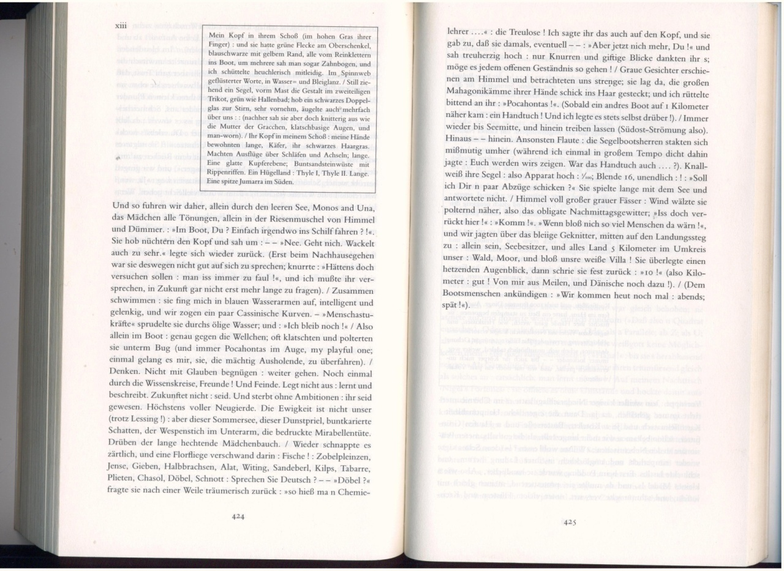

axlo warsuli
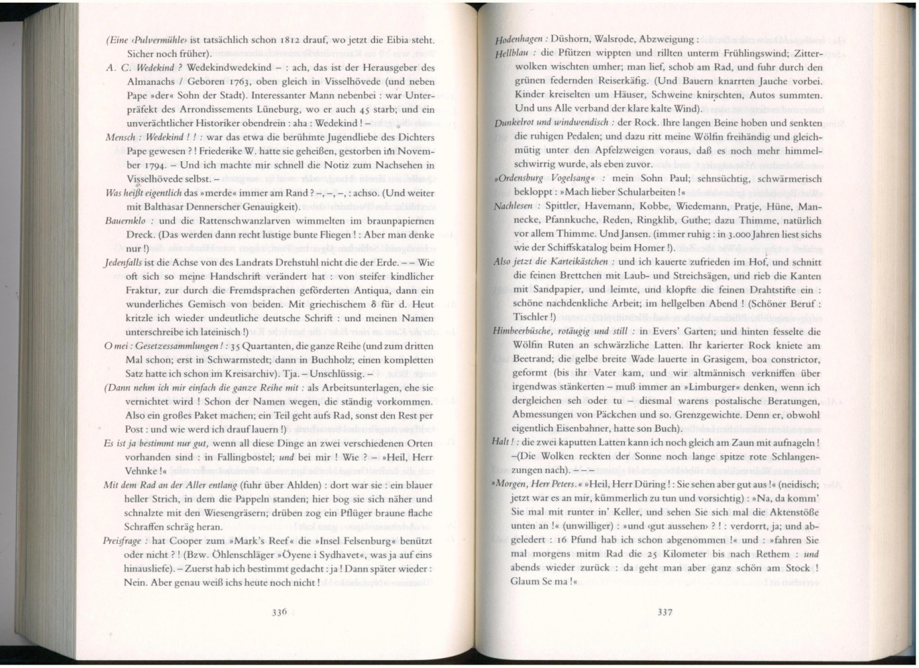
azrTa xangrZlivi TamaSi
